**PRACTICAL NO.7**

**7. Python and MongoDB**

**a. Connecting Python with MongoDB and inserting, retrieving, updating and deleting.**

Step 1: Install pymongo

In terminal:

pip install pymongo

**1) Insertion:-**

**Code:**

from pymongo import MongoClient

client=MongoClient("mongodb://localhost:27017/")

db=client["python_db"]

coll=db["emp"]

rec={"name":"ancel","age":20}

i=coll.insert_one(rec)

print(i)

p=coll.find()

for x in p:

    print(x)

**Output:**

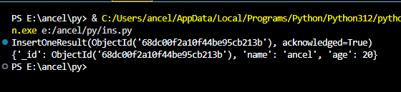

**Retrieving data:-**

**Code:**

from pymongo import MongoClient

c=MongoClient("mongodb://localhost:27017/")

db=c["python_db"]

coll=db["emp"]

r=coll.find_one({"age":20},{"_id":0})

print(r)

**Output:**

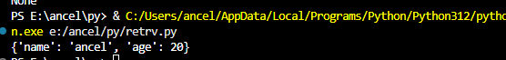

**Inserting multiple data:-**

from pymongo import MongoClient

client = MongoClient("mongodb://localhost:27017/")

db = client["python_db"]

coll = db["emp"]

records = [

    {"name": "ancel", "age": 20},

    {"name": "Rohit", "age": 25},

    {"name": "Sujal", "age": 22}

]

result = coll.insert_many(records)

print("Inserted IDs:", result.inserted_ids)

# Fetch and print all documents

for doc in coll.find():

    print(doc)

**Output:**

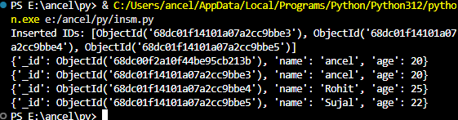

**Delete:**

**Code:**

from pymongo import MongoClient

c=MongoClient("mongodb://localhost:27017/")

db=c["python_db"]

coll=db["emp"]

r=coll.delete_many({"age":20})

for x in coll.find():

    print(x)

**Output:**

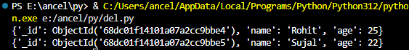

**Update:**

**Code:**

from pymongo import MongoClient

c=MongoClient("mongodb://localhost:27017/")

db=c["python_db"]

coll=db["emp"]

r=coll.update_many({"name":"ancel"},{"$set":{"department":"IT"}})

for x in coll.find():

    print(x)

**Output:**

